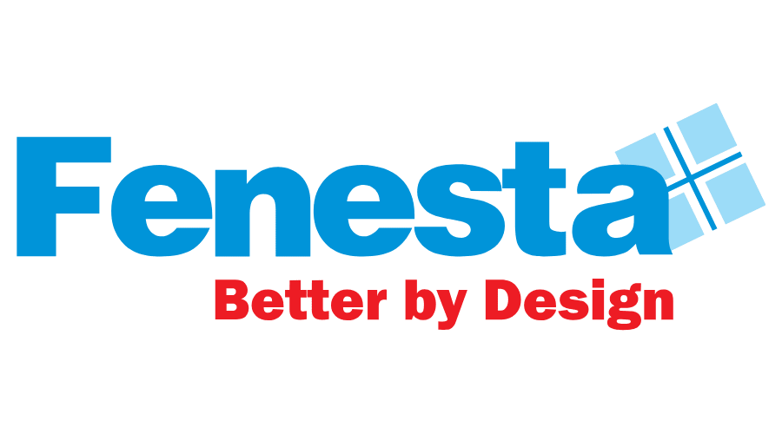
FENESTA EXPANDS ITS RETAIL PRESENCE IN INDORE, MADHYA PRADESH
Indore, 9 October, 2023: Fenesta, India’s largest Windows and Doors Brand which is also the market leader in its segment, reinforced its retail expansion with the opening another new showroom. The exclusive showroom BK Home Solutions is located at 215, Usha Nagar Main, Ranjit Hanuman Road, MHOW Naka, Indore, Madhya Pradesh – 452009 and brings the best in class Aluminum windows and Doors, uPVC Windows & Door and Solid Panel Doors.
Speaking on the occasion, Mr. Saket Jain, Business Head, Fenesta said, “Our steadfast commitment to our customers, coupled with our diverse product portfolio, has been a cornerstone of our continued growth. Each new showroom stands as a strong testament to the trust our customers have placed in us. These showrooms serve as dedicated spaces where customers can fully engage with our products, immerse themselves in our brand, and make informed choices. With the inauguration of our latest showroom, we are taking a significant step forward in realizing our strategic vision of establishing a strong nationwide presence. This expansion reflects our enthusiasm and determination to reach customers across the country, bringing our high-quality products and brand experience closer to them.”

With this launch, Fenesta marks another milestone to ensure an interactive and informative buying experience for our existing and potential customers. Fenesta Showrooms have been successfully contributing to a significant customer reach and positioning as a market leader. With the rapid growth in Aluminum windows and Doors, uPVC Windows & Door and Solid Panel Doors categories in India, the brand endeavors to further increase its market share and maintain its leadership position in future.

He further added that “With unwavering support and unwavering belief from our partners and stakeholders, we have reached this remarkable standpoint. Our journey thus far has been nothing short of extraordinary, and now we stand poised for accelerated growth in the years ahead. This pinnacle of success has been achieved through the synergy of a robust marketing strategy, a diverse array of products, and a resolute focus on Tier 2 and Tier 3 markets. Every aspect of our approach is meticulously designed to cultivate engagement, impart knowledge, and create lasting memories for our valued customers.”

The Fenesta showroom located at 215, Usha Nagar Main, Ranjit Hanuman Road, MHOW Naka, Indore, Madhya Pradesh – 452009 showcases a range of products from windows, doors and various design and color possibilities. With this launch, Fenesta now has presence in more than 350 locations.

Fenesta is the only company in India to control the entire supply chain starting from the making of uPVC that goes into making the profile, to installation of end product, as well as after sales service. The range of products is specially designed in UK and Austria to give consumers a well-engineered but contemporary style.
The products at Fenesta go through stringent tests and quality check at every step to ensure performance in India’s varied and extreme climates. Fenesta products are immensely popular amongst leading builders, architects and interior designers across the country for its noise insulating, rain insulating, dust proof features without compromise on aesthetics.
###
About Fenesta Building System:
Fenesta is India’s largest windows and doors brand and a part of the Rs.12,080 Cr conglomerate DCM Shriram Ltd. Its installations across more than 4,00,000 homes have already crossed the magical 4 million mark. Empowered with the knowledge of India's extreme conditions, Fenesta has designed uPVC windows and doors that are able to withstand India's extreme climate also. After uPVC, Fenesta took another technological leap when it introduced its ultra-luxury Aluminium Windows and Doors and Solid Panel Doors. Headquartered in Gurgaon, Fenesta has more than 300 dealer showrooms and nine Signature Studios supporting its presence in more than 350 cities. With dynamic direct sales force, Fenesta has successfully expanded its reach internationally, penetrating markets in the Maldives, Kenya, Nepal, and Bhutan. Fenesta offers a complete customized end-to-end solution: survey, design, manufacture, delivery, installation and service to all its customers. The entire process is synchronized with the pace of each project. As a leader in the category, Fenesta takes pride in its ability to serve individual homes and large developers with equal ease.

For further information, please reach out to:
Gurudiksha Kaur | gurudiksha.kaur@adfactorspr.com

Rahil Siddiqui | rahil.siddiqui@adfactorspr.com

